Lab Objective

Learn how to Importing and Copying GPOs

**Lab Procedures**

**1.** On RWDC01, using Group Policy Management, navigate to and click **the Group Policy Objects** container.

**2.** Click GPO2. Then click the Settings tab to verify the current settings.

**3.** If an Internet Explorer message box opens, click Add on the Internet Explorer message box. Then click Add in Trusted sites dialog box, and click Close.

**4.** Right-click GPO2 and click Import Settings.

**5.** When the Welcome screen opens, click Next.

**6.** On the Backup GPO page, click Next.

**7.** On the Backup location page, click Next.

**8.** Click GPO7 and click Next.

**9.** On the Scanning Backup page, click Next.

**10.** On the Migrating References page, with the *Copying them identically from the source* selected, click Next.

**11.** When the wizard is complete, click Finish.

**12.** When the import is complete, answer the following question, and click OK.

|  |  |
| --- | --- |
| Question 2 | What is the only item that did not succeed? |

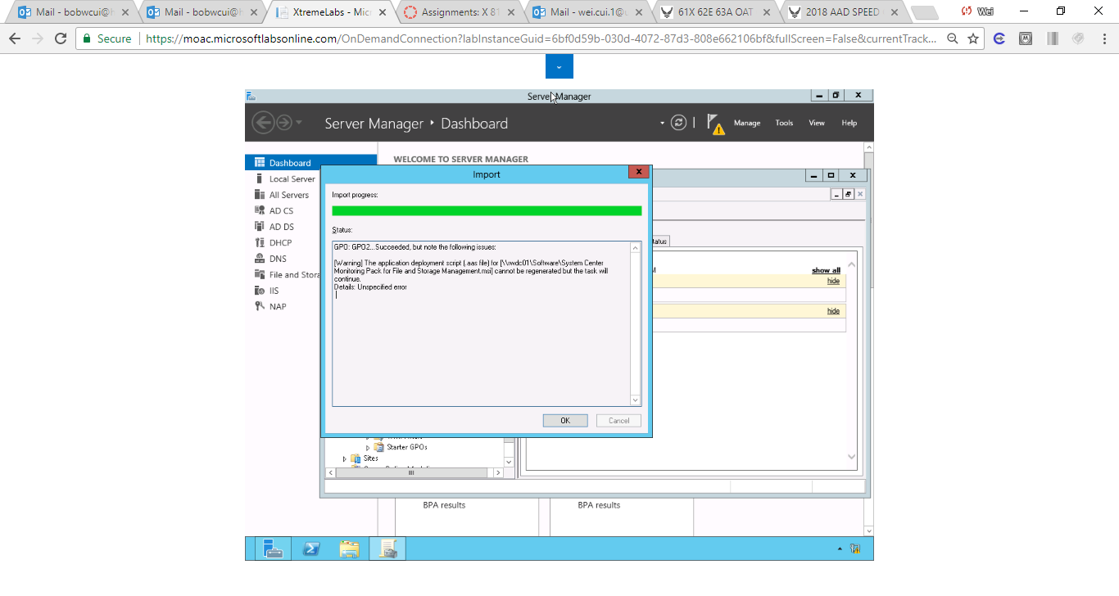

Figure Screenshot shows the item not succeed.

**13.** To copy a GPO7, right-click GPO7 and click Copy.

**14.** Right-click Group Policy Objects container and click Paste.

**15.** When the Copy GPO dialog box appears, click *Use the default permissions for new GPOs*. Click OK.

**16.** When the copy is complete, click OK.

**17.** Right-click the Copy of GPO7 and click Rename. Type **GPO8** and press the Enterkey.

**18.** Lastly, instead of always creating a new GPO, you can also link a container to a current GPO. For example, right-click Service Accounts OU and click Link an Existing GPO.

**19.** When the Select GPO dialog box opens, click GPO7 and click OK.

**20.** Click GPO7in the left pane. Click the Scope tab in right pane.

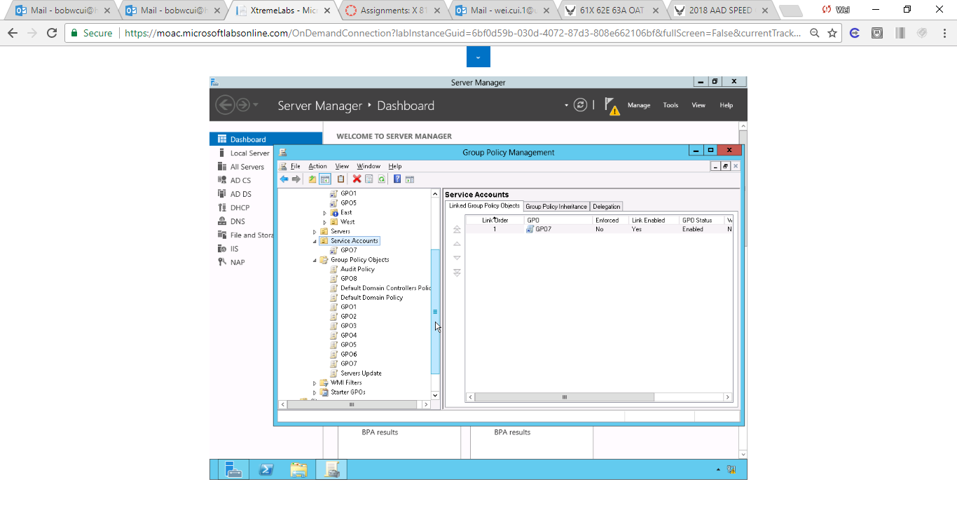

Figure GPO7 is linked in Service Accounts OU

**21.** Take a screen shot of the Group Policy Management window by pressing Alt+Prt Scr and then paste it into your Lab21_worksheet file in the page provided by pressing Ctrl+V.

|  |  |
| --- | --- |
| Question 3 | What are the two OUs that GPO7 is linked to? |

**22.** Close the Group Policy Management console.

End of exercise

**Lab Summary**

During this exercise, you configure the desktop wallpaper and screen saver settings. The screen saver settings are used to help protect a system by activating a screen saver when a user walks away from his or her computer for more than 15 minutes. If the screen saver is activated, the user will have to input his or her password to resume.